Philadelphia university  Lecturer : Ms. Soha Telfah  Coordinator : Dr. Muwaffag Badawneh  Internal examiner : Dr. Muwaffag Badawneh |  | Faculty of pharmacy  Department of pharmaceutical science

Student name: student number:
Course name: phytochemistry 2^{ed} semester of academic year 2008/2009
Course number: 540302 section: 1 date: 5/4/2009
First/second/final exam duration of exam:1 hour

Information for candidates
1. This examination paper contains 3 questions in10. Pages, totalling 50 marks.
2. The marks for parts of questions are shown in round brackets.

Notes to candidates
1. You should attempt all questions.
2. You should write your answers clearly

Part i. Basic notions
Objectives. The aim of the questions in this part is to evaluate the required minimal student knowledge and skills. Answers in the pass category represent the minimum acceptable standard ( 5 Marks).

Part I. Basic Notions
Objectives. The aim of the questions in this part is to evaluate the required minimal student knowledge and skills. Answers in the pass category represent the minimum acceptable standard (7.5 marks).
Q.I. Fill the following table with suitable answer in B in correspondence to column A:

 | A | B
1 | Enzyme that can be stimulated by flavonoid
2 | Anthraquinone are contraindicated in patient with hypertension because……
3 | Deactivation of enzymes during the extraction process of glycoside can be done by: | 1-  2-
4 | Defatting for coumarines can be done by:
5 | Main use for Hypericum perforatum is:  Main side effect is | ………………  …………………..
6 | Example of furanocoumarin, used to treat renal stone
7 | One function of glycosides in the plant: | 1-
8 | Example of naphthadianthrone compound
9 | Example of anthraquinone dimmer
10 | Example for glycoside utilized in defense mechanism to produce toxic substance
11 | Difference between Aloe vera and Aloe ferox | 1-  2-
12 | Example of biflavonoids found in Ginkgo biloba
13 | Color produced after spraying coumarin with ammonia
14 | Semi synthetic flavonoid
15 | Synthetic coumarin
16 | Antidote for warfarin toxicity
17 | PUVA stands for
18 | Example for pharmaceutical product containing rutoside
19 | Positively charged flavylium ion is
20 | Main activity of flavonoids include | 1-  2-
21 | Botanical source for Dicoumarol
22 | Evaporation for solvent for the purpose of concentration under reduced pressure can be done by
23 | Flavonoid exist in Silybium marianum responsible for hepatoprotective effect is called:

Part II. Familiar Problems Solving
Objectives. The aim of the questions in this part is to evaluate that the student has some basic knowledge of the key aspects of the lecture material and can attempt to solve familiar problems ( marks).

Q.I. Circle the most appropriate answer:

Q.1. In comparison with primary metabolites, secondary metabolites are considered:
A. More pharmacologically active.
B. With wider distribution.
C. An expression of plant identity.
D. Both A and C.
E. All of the above.

Q.2. Suitable solvent for steroidal glycoside:
A. Pet ether.
B. chloroform
C. methanol
D. 50% ethanol.

Q.3. Glycosides are optically active but its aglycone is not essentially optically active:
A. True B. false

Q.4. Gitaloxigenin is the aglycone of gitaloxin:
A. True B. false

Q.5. glycoside occurs in cell sap while corresponding aglycone exist in the epidermal layer or cuticle:
A. true B. false

Q.6. According to its configuration α-glycosides are considered with ………..distribution than β-glycosides:
A. More B. Less

Q.7.. One of the following is not primary metabolite:
E. fructose
A. Proline.
B. aristolochic acid.
C. Morphine.
D. sesame oil.

Q.8. Physicochemical properties of coumarin, all of the following are true EXCEPT:
A. Detection of TLC spot can be done by ammonia reagent which well give blue yellow or purple color.
B. 7-Hydroxy derivative should not be extracted in basic condition, slightly acidic condition is preferred.
C. Isolation and purification can be done by different chromatographic techniques.
D. Biosynthetic pathway involved is exclusively acetate pathway.

Q.9. Aloin A could be considered as ……………… glycosides for aloinoside A:
A. Primary. B. Secondary.

Q.10 . ……………..Came exclusively from shikimate pathway, while………… Came from acetate and shikimate pathway:
A. Flavonoids, Anthraquinone.
B. Coumarins, Anthraquinone.
C. Coumarin, Anthocyanins.
D. Anthraquinone, Coumarins

Q.11. In comparison with fresh plant, dried plant material containing anthraquinone is characterized by the following:
A. Exist in the oxidized form.
B. Dimerization.
C. Glycoside formation.
D. All of the above.

Q.12. Coumarin compounds:
A. Aesculin; but not its aglycon; aesculitin, is used as venoactive agent and to treat hemorrhoid. Orally or topically
B. Vitamin K can be used as antidote for warfarin toxicity
C. mellilotoside should be hydrolyzed then dimerized by fungus to for Dicoumarol.
D. Khellin is linear furanocoumarin has of phototoxic effect.
E. tow of the above.

Q.13.Ammonia can be used to detect color change if it was used as spraying agent for the following agent EXCEPT:
A. Chalcone.
B. Aurone.
C. Coumarins
D. Anthraquinone.
E. none of the above.

Q.14 All of the following are true concerning glycoside EXCEPT:
A. Sinigrin is example of S- glycosides.
B. Primary glycoside for a certain compound contains higher number of sugar than corresponding secondary one hence it is more water soluble.
C. Phenolic glycosides are generally regarded less water soluble than steroidal and terpenoidal once
D. β-glucoside is more common α -glucoside than, each has their own enzyme of hydrolysis. E. Two of the above.

Q.15. Concerning Ginkgo biloba, all of the following are true EXCEPT:
A. Flavonoids in the leaves of Ginkgo biloba are responsible for its antioxidant effect and treatment of venous and cerebral insufficiency "treatment of Alzheimer".
B. Ginkgolides are diterpenoids which are inhibitors for PAF; which is a phospholipids mediator in inflammation, allergy and thrombosis.
C. Flavonids are represented as flavonol O- glycoside, biflavone which are 3'-8'' is also common, bilobetol is example.
D. Goinkgo extract should be standardized for flavonoid mixture and diterpene, it contains more diterpene

Q 16. Concerning cyanindin, all of the following is/are true EXCEPT:
A. They are Positively charged compounds.
B. Structurally related to flavonoids with glycosidic and phenolic nature, thus it is highly soluble in water and acetone.
C. Very unstable compound and highly affected by pH changes, under highly basic condition the ring open reversibly to form chalcone structure which is colored yellow.
D. Both A and C.
E. Both B and C.

Q 17. Concerning anthocyanins, all of the following are true EXCEPT:
A. At least one hydroxyl group at C-7, C5 or C-4' must remain free to allow the quinoid formation.
B. They are usually glycosylated at C-3.
C. They are antioxidant, antioedema, substitute synthetic dye stuff because of safety and stability.
D. The leaves, fruit of Vitis venifera "Vine" are used to treat venous insufficiency, lymphatic insufficiency.

Part iii. Unfamiliar problems solving
Objectives. The aim of the questions in this part is to evaluate that the student can solve familiar problems with ease and can make progress towards the solution of unfamiliar problems, and can set out reasoning and explanation in a clear and coherent manner (5 Marks).

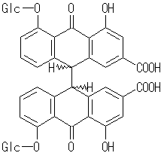

Q.18. Concerning the previous structure, all of the following are true EXCEPT:
A. Bidesmoside, heterodianthrone from the barks of Cassia acutifolia .
B. Can form salt by the addition of alkali.
C. To get the free active aglycone the glycosides should be hydrolyzed using acid hydrolysis "with heat" and oxidative cleavage in neutral condition.
D. Should not be taken with cardiac glycosides and antibiotics.
E. pharmacopeia requires the assay of the anthraquinone glycoside in senna leaves since it is the pharmacologically active part.

Q.19. one of following medicinal plant does not exist in Jordan:
A. Milk thistle.
B. Ginkgo biloba.
C. Hypericum spp.
D. Vitis venefera
E. Aloe spp.

Q.20 United state FDA recognizes the activity for flavonoids and stated the word to treat or cure for their preparation.
A. true B. false

Q.21. hesperidin differs from diosmin by all of the following EXCEPT:
A. Water solubility; since hespiridin is glycosylated it is more water soluble than diosmin.
B. The former is natural while the later is semi synthetic.
D. Degree of unsaturation between C-2 andC-3.
E. none of the above.

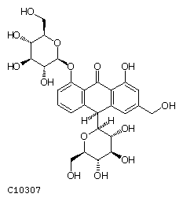

Q.21 Concerning the previous structure, all of the following are true EXCEPT:
A. Botanical source is the bark of Rhamnus purshiana Rhamnaceae.
B. The structure is Bidesmoside.
C. Stereoisomerism result from chirality's at C-10.
D. The previous compound acquires strong pink colored if Mg acetate is added directly to it, but faint unstable color if NaOH is used instead.
E. Both B and D.

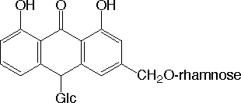

Q.22. Concerning the previous structure, all of the following are true EXCEPT:
A. Upon oxidative hydrolysis in acidic media "and heat" the aglycone produced is the same as aglycone produced from Cascaroside A
B. Termed Aloinosides found in the dried exudates of aloe vera Liliaceae
C. The previous compound is the main one responsible for healing properties for aloe preparation.
D. tow of the above.

Q.23. The aglycon of the following glycoside is identical:
A. one half of Sennoside B, Cascaroside B, Aloinosides A
B. Sennoside A, Cascaroside C, Aloinosides A
C. Cascaroside D, Aloin A
D. Rutin, hespiridin.
E. Aloin A and Aloinoside B, Cascarosides A and B.

Q.24. Concerning anthraquinone compounds:
C. The glycoside is soluble in absolute alcohol.
D. Stereochemistry result from chirality at C-10.
A. Anthraquinone usually exist as 1,8-Dihydroxy compounds
B. C-glycoside is usually positioned at C-10.
E. The optical activity is attributed mainly to the sugar part

Q. 25 The following product is not considered as photodynamic:

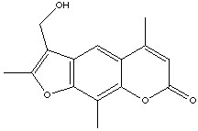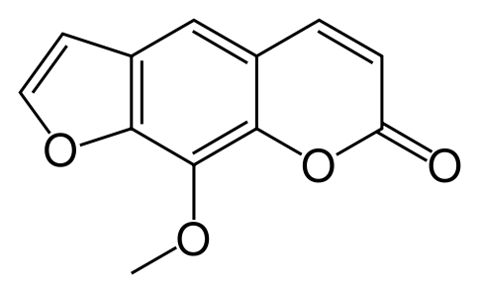

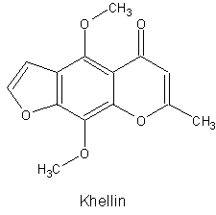

Q.26. Circle in the following the compounds which well have the same hydrolytic product :
(more than on answer can be possible):
A. cascrosides A, B, C, D.
B. aloin A +B and aloinoside A+B.
C. cascaroside (A,B,C,D) and sennosides.
D. aloins and aloinosides and cascarosides A and B.

Student name:
Student number:

 | A | B | C | D | E |  | A | B | C | D | E
1 |  |  |  |  |  | 13
2 |  |  |  |  |  | 14
3 |  |  |  |  |  | 15
4 |  |  |  |  |  | 16
5 |  |  |  |  |  | 17
6 |  |  |  |  |  | 18
7 |  |  |  |  |  | 19
8 |  |  |  |  |  | 20
9 |  |  |  |  |  | 21
10 |  |  |  |  |  | 22
11 |  |  |  |  |  | 23
12 |  |  |  |  |  | 24
 |  |  |  |  |  | 25

